**4. EVALUATION**

Testing is an essential part of the design process. This section describes the tests performed in order to verify compliance with the technical design constraints discussed previously and listed in Table 4.1 below. This includes system tests as well as testing of the individual components of the design.

**Table 4.1 Technical Design Constraints**

|  |  |
| --- | --- |
| **Name** | **Description** |
| Temperature | The device must operate at a temperature of 0℃. |
| Accuracy | The device must determine the liquid level with an accuracy of ±5% of the actual amount. |
| Wireless Transmission Distance | The WiFi connection must reach up to 9 m. |
| Battery Life | The device must run continuously for 16 hours using a battery. |
| Noisy Environment | The readings of the sensor must be accurate within an environment of 80 dB. |

**4.1. Test Certification -- Temperature**

Due to kegs often times being refrigerated during use, the device must operate normally when in low-temperature environments. There is no need for the kegs to be put below freezing temperatures, therefore the device must operate down to 0℃, but not lower. To test this, the device is placed in a 0°C environment, and the performance is verified by comparing to operation at normal room temperature. The device is tested at room temperature as well as at 0°C to verify that the readings are not affected.

**Table 4.1.1 - Temperature tests**

|  |  |  |  |
| --- | --- | --- | --- |
| **Temperature** | **Expected Result** | **Actual Result** | **% Error** |
| 32°C |  |  |  |
| 20°C |  |  |  |
| 10°C |  |  |  |
| 0°C |  |  |  |

**4.2. Test Certification -- Accuracy**

Having precision and accuracy is essential to the success of this device. If the readings are inaccurate or inconsistent, it renders the product unusable. To test the accuracy of the device, and thereby determine the usefulness of the product, the design team borrowed multiple kegs from the Mayhew Junction Brewing Company. The borrowed kegs were all one-sixth barrel kegs and were filled to various known levels. One keg was empty, one filled one-third of the way full, another two-thirds of the way full, and one keg filled completely. This allows for testing against known values.

In addition to testing the kegs filled to various levels, a test was performed to determine if variations in keg manufacturer affect the reading of the device. A one-sixth barrel keg from a different vendor was tested which was one-third of the way full to determine if the slight variance in kegs from different manufacturers affects the performance of the device. This alternate keg was filled to one-third of its capacity not only to retest the device’s accuracy but also to compare with the results from the one-third keg from Mayhew Junction. Table 4.2.1 shows the results of the tests.

**Table 4.2.1 - Accuracy tests**

|  |  |
| --- | --- |
| **Actual value** | **Device reading average over ten tests** |
| 0% |  |
| 33% |  |
| 66% |  |
| 100% |  |
| 33% Non-Mayhew keg |  |

The component most critical to getting a consistent and accurate measurement from the device is the vibration sensor. Before testing the accuracy of the estimated liquid level, the vibration sensor was tested to determine the reading strength and consistency of the sensor when attached to the side of the keg. Because the Raspberry Pi Zero W does not have any analog GPIO pins built-in, an analog to digital converter was needed to read from the sensor. Figure 4.2a shows the results of the I2C test to ensure a connection could be established between the Pi and the ADS1115, which is the analog to digital converter used in the product.

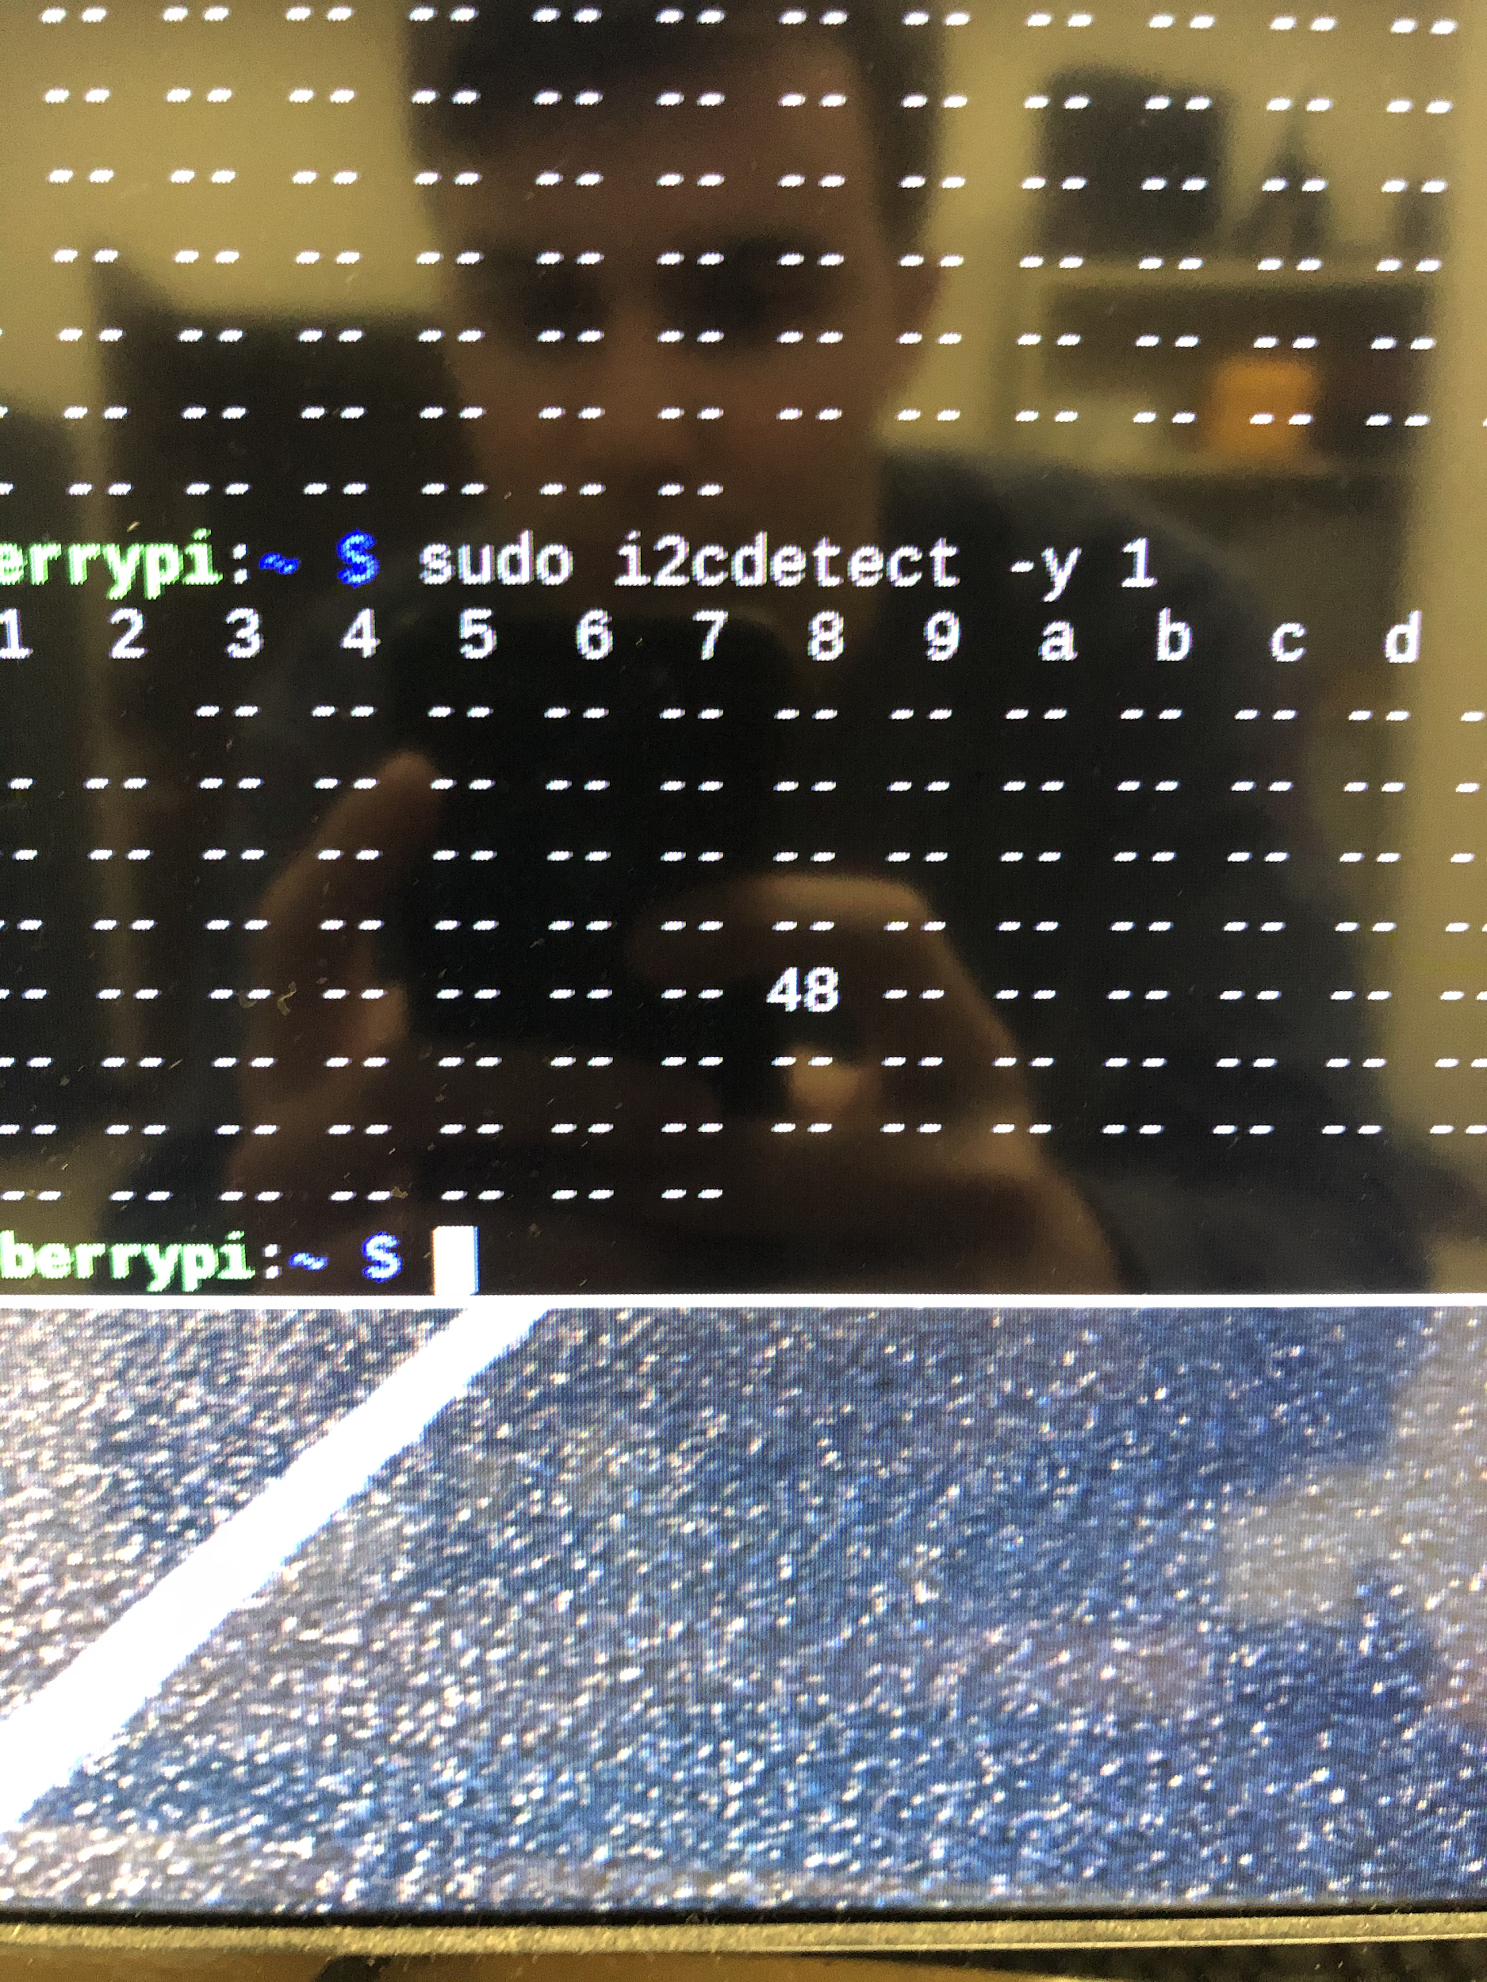

**Figure 4.2a - I2C detection of the A/D converter for the vibration sensor**

Figure 4.2b shows the signal captured when the keg was struck by hand while the vibration sensor was attached. The image clearly shows the impact point and demonstrates the strength of the signal captured by the vibration sensor. Capturing the generated vibration is the key function of the product, and this test demonstrates the effectiveness of the vibration sensors.

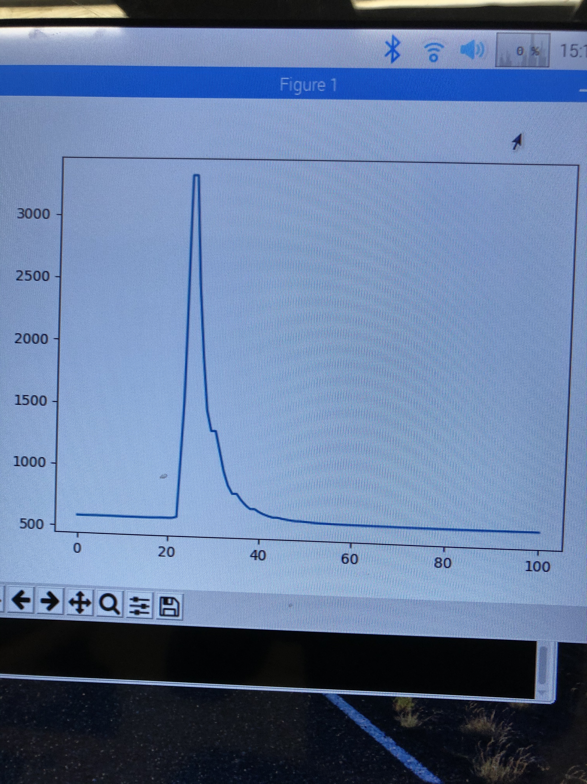

**Figure 4.2b - Signal output of the vibration sensor**

**4.3. Test Certification -- Wireless Transmission Distance**

Testing the wireless distance constraint requires being off-campus with a personal wireless router. With the Raspberry Pi connected to the wireless network, it is then taken a distance of 9 meters away from the router. The distance is measured with a tape measure capable of extending 9 meters. Ensuring that the device is still connected to the network demonstrates adherence to the given constraint.

**Table 4.3.1 - Transmission tests**

|  |  |  |
| --- | --- | --- |
| Distance (meter) | Signal Strength (dBm) | Physical Structure Interference (Y or N) |
| 3 meters |  |  |
| 6 meters |  |  |
| 9 meters |  |  |
| 12 meters |  |  |

**4.4. Test Certification -- Battery Life**

To test the battery life constraint, the device will operate for 16 continuous hours to ensure the constraint is met. The solenoid activation and performance is also measured intermittently to ensure the draining battery does not impact performance over the device’s 16-hour lifespan. Using the equations below, the required mAh is found to be 202.5 mAh. Our battery outputs 500 mAh which is suitable to operate within the given condition.

$I_{needed}$ = $I_{Raspberry Pi- Zero W}$ + $I_{solenoid}$ + $I_{sensors}$ = 120mA [19] + 250mA +<1mA ≈ 0.371mA [Eq. 4.4.1]

30 seconds/measurement * 4 measurements per hour * 16 operation hours = 32 minutes in operation [Eq. 4.4.2]

0.371A * 0.53 hours = 197.9 mAh for operation [Eq. 4.4.3]

0.3mA low-power mode * 15.47 hours = 4.6 mAh total power during low-power mode [Eq. 4.4.4]

197.9 + 4.6 = 202.5 mAh , total battery requirement [Eq. 4.4.5]

**Table 4.4.1 - Battery tests**

|  |  |  |
| --- | --- | --- |
| Time (hr) | Voltage (V) | Percentage left (%) |
| 4 hours |  |  |
| 8 hours |  |  |
| 12 hours |  |  |
| 16 hours |  |  |
| 20 hours |  |  |

**4.5. Test Certification -- Noisy Environment**

In order to ensure the device operates properly in a typical environment, it had been tested under conditions up to 80 dB. 80 dB was used because a bar or restaurant is approximately 85 dB loud, and since the device is in a refrigerated casing, this attenuates the noise somewhat [1]. The device was placed near a speaker and the speaker was turned up to a sufficient amount until the proper noise level was reached. To ensure that the sound was at an appropriate volume, an app called Decibel X, made by SkyPaw Co, Ltd, was used. Once the sound pressure level was adequate, a test was performed to verify the device still measured accurately under these conditions.

**Table 4.5.1 - Interference tests**

|  |  |  |  |
| --- | --- | --- | --- |
| **Volume in dB** | **Expected Result** | **Actual Result** | **% Error** |
| 20 dB |  |  |  |
| 40 dB |  |  |  |
| 60 dB |  |  |  |
| 80 dB |  |  |  |

**4.6 Test Certification — System Test**

Once each subsystem is in place, a full system test is performed. First, the device is turned on via a switch and set-up using the smartphone application. Once this is completed, the device begins to initiate the first test. The Raspberry Pi sends a signal to the relay driver, which diverts power from the battery to the solenoid. This causes the solenoid to fire, striking the side of the container with approximately 31 N of force. As the container resonates, the piezoelectric sensor converts mechanical stress to an electric potential. This current is sent to the analog-to-digital converter for processing.

Using a sample clock, the A/D converter samples the signal at a rate of 860 samples per second and converts each sample to a digital value. This is sent to the Raspberry Pi over an I2C serial bus. Next, the signal is processed using a Fourier transform, which converts the signal from the time domain to the frequency domain. Based on the frequency response, the liquid level is determined and uploaded to an FTP server. Finally, the smartphone application retrieves the percentage level and displays it to the user.

**References**

[1] “Sound Effects Decibel Level Chart.” creativefieldrecording.com. <https://www.creativefieldrecording.com/2017/11/01/sound-effects-decibel-level-chart/> (accessed Nov. 10, 2019).